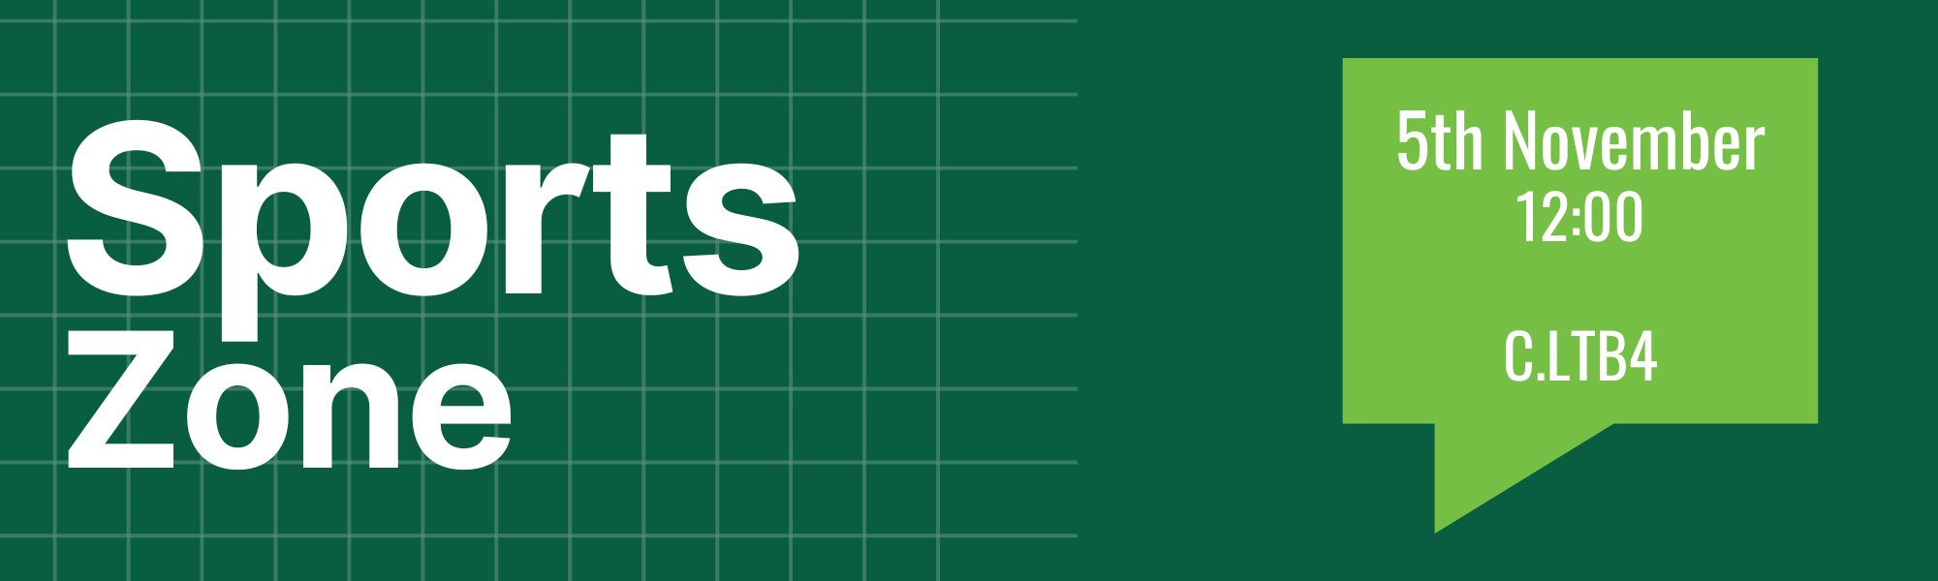

Minutes
- Welcome
- In Attendance
  - Members Present
    - Laura Shaw, Sports Union President
  - In Attendance
    - 56 Sports Union Members
    - 31 Clubs - American Football, Athletics, Badminton, Basketball, Cheerleading, Cycling, Dance, Equestrian, Fencing, Handball, Judo, Kayak, Men’s Football, Men’s GAA, Men’s Hockey, Men’s Rugby, Mountaineering, Netball, Parkour, Polo, Shinty, Snowsports, Sub Aqua, Swimming, Taekwondo, Trampolining & Gymnastics, Volleyball, Water Polo, Women’s Football, Women’s Hockey, Women’s Lacrosse,
    - 2 Staff Support
  - Apologies
    - Sneha Mukerjee, Health and Wellbeing Officer
    - Benedicta Okhunlun, Communications Officer
  - Absent without apologies
    - 26 Clubs - Archery, Baseball, Boxing, BJJ, Cricket, Darts, Futsal, Ladies GAA, Golf, Handball, Men’s Lacrosse, Muay Thai, Orienteering, Parkour, Pole Fitness, Powerlifting, Rowing, Snowsports, Squash, Surf, Tennis, Touch Rugby, Triathlon, Ultimate Frisbee, Volleyball, Women’s Rugby
- Minutes Ratification
  - Minutes ratified by Callum Ball
  - No objections
- Challenges to Order Paper
  - No challenges to order
- Dates to Note
  - Movember – November
  - Beyond Equality – 18th and 19th November
  - SSS Boccia Festival – 31st November
  - Teaching ends – 29th November
  - Club Mark submission deadline – 29th November
  - Club Mark award meeting – 2nd December
- Elections & Resignations
  - By-elections
    - Benedicta Okhunlun
- Reports (the Sports Zone reports can be reviewed in the agenda) - Sports Zone 1 Agenda.docx
  - Sports Union President, Laura Shaw
    - 2378 Sports Union Members
    - 32 clubs with increased membership
    - Highlighted clubs that have significantly increased membership
    - Clubs have completed 175 fixtures so far and claimed 315 BUCS points
    - Highlighted success in both BUCS and SS competition
    - Thanked clubs for engagement with Full Time on Initiations and Show Racism the Red Card initiatives
    - Kit orders are being processed
  - Sports Participation and Engagement Volunteer Officer, Lauren Bullock
- N/A
  - Health and Wellbeing Volunteer Officer, Sneha Mukherjee
    - N/A
  - Sports Communication Volunteer Officer, Benedicta Okhunlun
    - Will be meeting with individual clubs and their social media representatives to discuss ideas for content in the future

- Updates, discussion and decision topics
      - Kit
        - Leisure orders through Rennie
        - Match kit design process
        - Volleyball & Women’s Lacrosse first clubs to sport new Adidas match kit
      - Movember
        - Marcus Scullion & Sophie Bryson Movember ambassadors
        - Important time of year for clubs to organise fundraisers
      - Boccia development
        - Advertisement of upcoming competition
        - Drop in session to be held
      - Funding applications
        - Development & Equipment fund process reminder
      - Club Mark
- Any Other Business
  - No other business
- Date of Next Meeting:
  - TBC
- Reserved business
  - N/A

