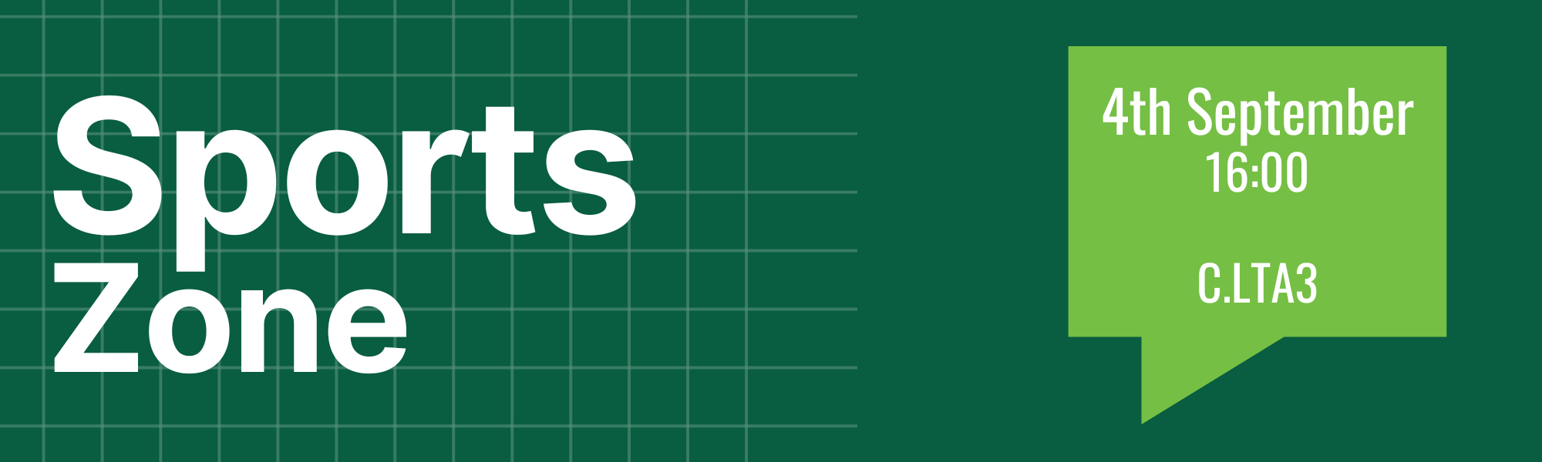

Minutes
- Welcome
- In Attendance
  - Members Present
    - Laura Shaw, Sports Union President
    - Lauren Bullock, Participation and Engagement Officer
  - In Attendance
    - 84 Sports Union Members
    - 33 – American Football, Archery, Athletics, Baseball, Basketball, Boxing, Cheerleading, Cycling, Dance, Darts, Equestrian, Fencing, Handball, Judo, Kayak, Ladies GAA, Men’s Football, Men’s GAA, Men’s Rugby , Mountaineering, Netball, Orienteering, Pole Fitness, Rowing, Shinty, Sub Aqua, Swimming, Trampolining & Gymnastics, Triathlon, Water Polo, Women’s Football, Women’s Hockey, Women’s Lacrosse
    - 3 Staff Support
  - Apologies
    - 2 – Powerlifting, Snowsports
  - Absent without apologies
    - 16 - Badminton, BJJ, Cricket, Futsal, Golf, Men’s Hockey, Men’s Lacrosse, Muay Thai, Parkour, Polo, Squash, Surf, Taekwondo, Tennis, Touch Rugby, Ultimate Frisbee, Volleyball
- Minutes Ratification
  - Minutes ratified by Lauren Bullock
  - No objections
- Challenges to Order Paper
  - No challenges to order
- Dates to Note
  - Sports Bazaar – 11th September
  - Sport Swap – 1st October
- Elections & Resignations
  - Elections
    - Angelica Oparinde and Connor Button elected as Presidents
    - Lucie Wiggins, Abby McMenamin and Sophie Cowie elected as Club Members
- Reports (the Sports Zone reports can be reviewed in the agenda) - Sports Zone 1 Agenda.docx
  - Sports Union President, Laura Shaw
    - Manifesto planning
    - Delivery of kit tender process
    - Gathering of best practice from other institutions
    - Increasing social media coverage
  - Sports Participation and Engagement Volunteer Officer, Lauren Bullock
- Increasing boccia and disability sport engagement
- Building relationships between university clubs and community clubs
- Building participation amongst recreational sport players
- Opening lines of communication between different clubs to share best practice
  - Health and Wellbeing Volunteer Officer, Sneha Mukherjee
    - N/A
  - Sports Communication Volunteer Officer, VACANT
    - N/A

- Updates, discussion and decision topics
  - Varsity workshop
    - LS – Results from workshop (held during Presidents’ Forum)
      - Consensus that existing Varsity rivalry with St Andrews is not in best interest
      - Conclusion was to initiate plans for replacement event
      - Greater internal focus on our clubs with both BUCS and non-BUCS sports represented
- Any Other Business
  - No other business
- Date of Next Meeting:
  - Tuesday November 5th 13:00
- Reserved business
  - N/A

