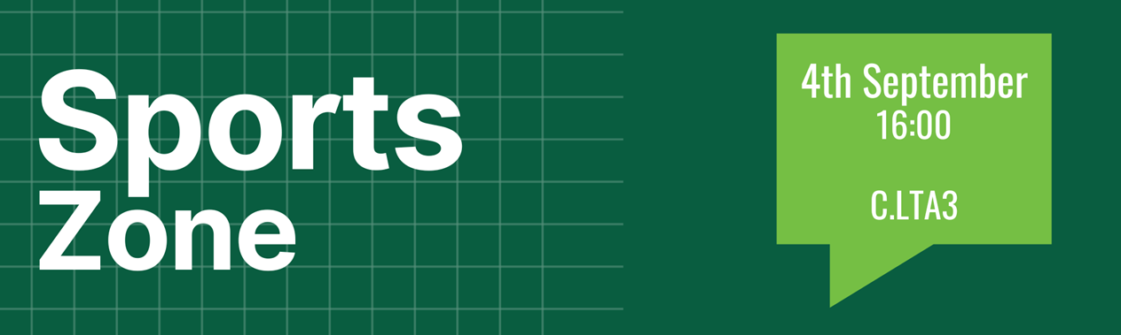

# Agenda

* Welcome and Attendance
* Minutes Ratification
* Challenges to Order Paper
* Dates to Note
* Elections & Resignations
* Reports
  + Sports Union President
  + Participation & Engagement Volunteer Officer Report
  + Health and Wellbeing Volunteer Officer Report
  + Communications Volunteer Officer Report
* Updates, discussion and decision topics
  + Varsity event replacement
* Any Other Business
* Date of Next Meeting: Tuesday November 5th 13:00
* Reserved business

# Paper A: Reports

### Sports Union President Sabbatical Report, Laura Shaw

[ADD SPORT PRESIDENT REPORT]

### Participation & Engagement Volunteer Officer Report, Lauren Bullock

* Increasing boccia and disability sport engagement
* Building relationships between university clubs and community clubs
* Building participation amongst recreational sport players
* Opening lines of communication between different clubs to share best practice

### Health & Wellbeing Volunteer Officer Report, Sneha Mukherjee

N/A

### Communications Volunteer Officer Report, VACANT

N/A