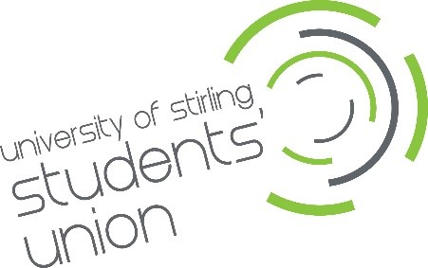
Union Shop staff

University of Stirling Students’ Union - Application Form

Your details

Full Name:

Address:

Postcode:

Student Number:

Phone:

Email:

Please note: You must be an enrolled student at Stirling University for the full academic year 2025/26 (September 2025 to April 2026).

Previous employers
Please tell us about a moment that you are proud of from a previous job, what skills did you use and what did you learn about yourself (up to 250 words).

Supporting statement
Please tell us why you applied for this internship and why you think you are the best person for the job.

Interview arrangements and availability
Please tell us if there are any reasonable adjustments we can make to help you with your application.
Interviews will be held on Thursday 1st May 2025, in person, no alternative dates are available.

Declaration
I confirm that to the best of my knowledge the information I have provided on this form is correct and I accept that providing deliberately false information could result in my dismissal.

Name:

Signature:

Date:

