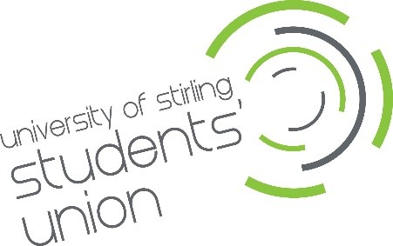
Green & Blue Space Hub Supervisor

University of Stirling Students’ Union - Application Form

Your details

Full Name:

Address:

Postcode:

Student Number:

Year of Study:

Level of Study:

Phone:

Email:

Please note: You must be an enrolled student at Stirling University for the full academic year 2025/26 (September 2025 to April 2026).

Previous employers
Please tell us about your supervisory experience from a previous job and what skills did you use within the role (up to 250 words).

Zero Waste/Circular Economy projects
Please tell us what experience you have, professional or personal, of zero waste and Circular Economy projects (up to 250 words).

Supporting statement
Please tell us why you applied for this role and why you think you are the best person for the job.

Interview arrangements and availability
Please tell us if there are any reasonable adjustments we can make to help you with your application.
Interviews will be held on Friday 2nd May 2025; no alternative dates are available. Interviews can be in person or via MS Teams.

Declaration
I confirm that to the best of my knowledge the information I have provided on this form is correct and I accept that providing deliberately false information could result in my dismissal.

Name:

Signature:

Date:

