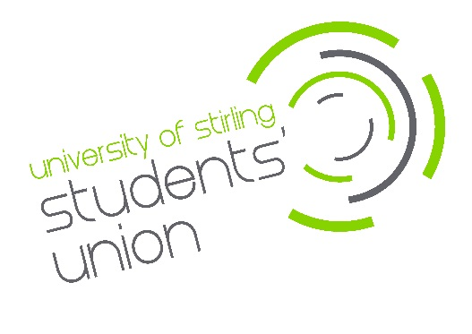
Supplier, Contractor

& Client Data

Privacy Statement

Introduction
University of Stirling Students’ Union (“we”, “our” or “us”) promises to respect any personal data you share with us, or that we get from other organisations and keep it safe. We aim to be clear when we collect your data and not do anything you wouldn’t reasonably expect.

Facilitating our legal requirements, organisation policy and services to our customers (consumers) through using your personal data allows us to make better decisions, communicate more efficiently and, ultimately, ensure you receive the services required.

Legal Basis
We fulfil our legal obligations for storing and processing personal information in the following ways:
• Contract – for example, for the employment of staff.
• Legal obligation – We operate a data sharing agreement with the University of Stirling to comply with our combined legal obligation to provide a Students’ Union. This allows students to automatically sign in and use the Union’s website for information and for activities such as voting in Union elections and purchasing club memberships.
• Legitimate interests – in seeking to enhance the student experience at Stirling, we believe it is in your interest for us to provide administration in support of your membership of clubs and societies/Sports clubs, as elected representatives and much more. In respect of purchases and for liaison with suppliers, we similarly process data for legitimate purposes.
Further information is available by contacting theunion@stir.ac.uk

Where we collect information about you from
We collect information in the following ways:
When you register as a supplier or contractor
When you register as a supplier with the Students’ Union you provide us with certain personal data.
When you register a client
When you register as a client with the Students’ Union you provide us with certain personal data.

When we collect it as you use our WEBSITES
Like most websites, we use “cookies” to help us make our site – and the way you use it – better. Cookies mean that a website will remember you. They’re small text files that sites transfer to your computer (or phone or tablet). They make interacting with a website faster and easier – for example by automatically filling your name and address in text fields. To find out more at cookies and how we use them, visit: https://www.stirlingstudentsunion.com/privacy/.
In addition, the type of device you’re using to access our website and the settings on that device may provide us with information about your device, including what type of device it is, what specific device you have and what operating system you’re using. Your device manufacturer or operating system provider will have more details about what information your device makes available to us.
What personal data we collect and how we use it
The type and quantity of information we collect and how we use it depends on why you are providing it.

Suppliers and contractors
In registering as a supplier we may ask you to provide us with the following personal information:

- Name
- Address
- Email
- Telephone number
- Bank Details
- Job Title

We will mainly use your data to administer our contracted duties with you.

Clients
In establishing a contract with us as a client we may ask you to provide us with the following personal information:

- Name
- Address
- Email
- Telephone number
- Job Title

We will mainly use your data to administer our contracted duties with you.

Communicating with you
We will only ever contact you to either fulfil a legal obligation (information on the Union’s activities related to this legal obligation) fulfil a contract (for example staff) or where we believe you have a legitimate interest in us communicating with you (for example to confirm an online shop order or matter relating to your participation in clubs and societies having bought a membership). The Union undertakes any communication in line with the Privacy and Electronic Communications (PECR) guidance. For any communication sent via our MSL system, you will be provided with an unsubscribe option to select your options for any future communication.

Security
Ensure the safety and security of your personal data is our primary goal. Relevant Union staff have access to process data and where this is the case, access is limited and locked to those who have authority to access it. Further information is available within the Union’s Data Protection Policy.

We may need to disclose your details if required to the police, regulatory bodies or legal advisors.

Retention
Further information on data retention can be found within the Union’s Data Protection Policy.
Profiling
Whilst we collect a variety of information to allow us to deliver our services, we do not engage in any activity that makes automated decisions.

Keeping your information up to date
We mostly use the record of members provided by the University of Stirling to maintain accurate data about you as described above. We really appreciate it if you let us know if your contact details change.

Your rights
You have the right to request to see a copy of the information we hold about you and to request corrections or deletions of the information that is no longer required. In some circumstances you may have the right to object to the processing of your personal data, to request it is erased where it is no longer required for the stated purposes, or that inaccurate information about you is corrected. For more information about your rights see the Students’ Union Data Protection Policy.

Contact details
If you have any questions relating to this policy or the way we are planning to use your information please contact:
Audrey Burns, Chief Executive, University of Stirling, Stirling, FK9 4LA
Tel: 01786 467166
Email: theunion@stir.ac.uk

Changes to this statement
We may change this Privacy Statement from time to time. If we make any significant changes in the way we treat your personal information we will make this clear on our Website or by contacting you directly.

