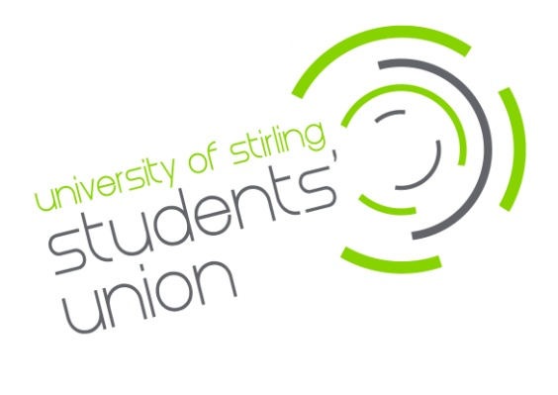

Recruitment
Postgraduate Research (PGR) Faculty Officer

£12.00 per hour (70 hours per year)
The University of Stirling Students’ Union is offering an exciting opportunity to join our Division and Faculty Officer team. We are looking for confident and enthusiastic people to provide student representation at a Faculty level, offering strategic input within academic divisions/faculties and to the University. The role of a Postgraduate Research (PGR) Faculty Officer exists to provide student representation at a Faculty and Division level, offering strategic input within their academic faculties, and playing a key coordinating role in improving the Postgraduate Research student experience across the University.
Main duties will include:

- Collaborate with your Faculty and Students’ Union to promote PGR student engagement within your Academic Faculty and across the University.
- Where applicable, oversee the work of Academic Representatives within your division, helping foster communication and escalation of any recurring issues to the appropriate person.
- Work in partnership with your Faculty’s PGR Director to improve and strategically develop the PGR student experience.
- Promote mechanisms to improve Learning, Teaching and the PGR Student Experience (such as the Postgraduate Research Experience Survey).
- Contribute to the organisation of Academic and Postgraduate Research Events, e.g. Research Conferences and Learning & Teaching Conferences.
- Develop at least one student-led project during your time in post.
- Undertake appropriate division and faculty projects to strategically improve the PGR experience and develop at least one student-led event during your time in post.
- When necessary, Division and Faculty Officers will be asked to participate as Student Reviewers in Learning and Teaching Reviews for academic Faculties/Divisions.

The hours for this post will be 70 per annum. The role will start beginning of August 2024 and will run to the end of June 2025.

You must be a student of the faculty for which you are applying.

Closing date for applications is Thursday 9th May 2024 (9am - GMT).
Interviews will be held week commencing 20th May 2024.

For more details or to apply for the position please go to www.stirlingstudentsunion.com/recruitment.

