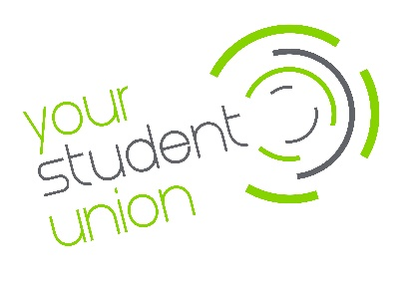
Advocacy Service & confidentiality

In using the University of Stirling Students’ Union advocacy service, there is a legitimate interest in providing you with the advice you need in the most efficient manner. To do so, we will use the information provided by you and during any consultations with our team to create a case record of your individual circumstances and the resulting discussions, cross reference information from our student records (provided by the University at enrollment), tailor our guidance to your needs and create anonymised statistical reports to further the service and University experience.
The University of Stirling Students’ Union does not share your data with third parties without your explicit consent unless there is genuine concern for the safety and well-being of the individual or others though we would normally seek to discuss this first before disclosure.
We will only ever share your data in other circumstances if we have your explicit and informed consent.
www.stirlingstudentsunion.com/privacy

